Trustees Report Year Ending 31 March 2024
Signed on behalf of the charity’s trustees.
Signature Full name: Sandra Elizabeth Webb
Position: Founder and Chair of Trustees
Date: 23rd April 2024
sandie@chippenhamhub.co.uk
trustees end of year report
31st March 2024

History
The Hub evolved from a post covid observation that despite there being many organisations and groups that responded to consequences of the pandemic, there was no central town hub to co-ordinate, assimilate need, and signpost. This recognised need resulted in a small team establishing a totally independent charity that was registered as the Chippenham Community Eco Hub. Some capital funding was established alongside a seed-funding grant from Chippenham Borough Lands Charity who contributed towards employing a manager for the first two years.
The main philosophy was, and is now, that all action and direction is based on what is good for Chippenham.
Vision

Chippenham Community Hub puts the needs of people above all other considerations to serve the community of the town and surrounding villages. It is based on ‘Rays Law’ that when a person walks through the door with a problem they should walk out on the way to a solution.
Charitable Objectives
• Operate for public benefit.
• Promote social inclusion/relief of poverty.
• Signpost and disseminate peoples need to registered organisations/charities.
• Promote sustainability and environmental responsibility.
• Operate independently for public benefit.
• Work for and be guided by the needs of the community.

Charitable Aims
• Assist community agencies & neighbourhood groups to offer a range of activities/services and respond to community needs.
• Encourage social inclusivity through group activities
• Act as a place of learning, education, and skills development to facilitate employability
• Provide a non-threatening equal opportunity environment for people to become involved, aware of opportunities, and undertake developmental activities
• Offer multiple services under one roof that meet the needs of the local community, encouraging social gatherings, whilst offering support.

2023/2024
In the third year of its operation the Hub has established a thriving base for the local community:
• Providing a safe, warm, and welcoming environment with consistent opening hours and messaging.
• Working with organisations embracing a portfolio of best practice ensuring that all necessary policies and procedures are in place.
• Addressing and responded to ongoing local and national community demands.
• Establishing Hub visitors needs and signposting to appropriate services; continuing to build partnerships to ensure effective referral routes.
• Continued to grow the community regeneration vision of Chippenham town centre for the benefit of both its residents and surrounding villages.
• Promote and work to achieve positive mental health.
• Engender a positive environment where community comes first and people always come before politics and personal agendas.

Operational Considerations
The Hub has a board of four trustees with day-to-day work led by the manager, trustees, and well-trained volunteers all working together. This reflects its basic philosophies in a local approach whilst being essentially holistic and inclusive.
It accords with the intention “to undertake initiatives throughout the communities to enhance their educational, economic, environmental and social potential “.
The trustees meet regularly, and all meetings have agenda and recorded minutes.
The independence and self-sufficiency of the Hub has been a cornerstone to the way it operates, putting people and the community at the front of all work streams and of decision making.
While this is the backbone to the organisation, there is also flexibility to accommodate and work with others; albeit this sometimes being the most challenging aspect of Hub work.
The fundamental elements of CCHC’s business development will continue to be dependent on building mutually beneficial relationships with the community and its base organisations.
The Hub consistently supports and attracts those experiencing or at risk of, social and/or economic exclusion.
As an inclusive organisation there are no exclusions with priority groups that include: -
• Older people
• Carers
• People with disability
• Those on low income
• People experiencing “worklessness”
• Those most marginalised from paid employment
• Local ethnic minorities, immigrants, refugees
• The LGBT+ community

Partner Organisations and Community Activities:
Wiltshire Council; Department for Work &Pensions; Chippenham Health and Wellbeing Team; Chippenham Town Centre Development Team; Knatty Knitters/Cast-offs; Chippenham Artists; Wiltshire Sight; Rethink Mental Health; Wiltshire and Swindon Youth Commission; North Wiltshire Community Club; Afritha Lace Makers; Chippenham Borough Lands Charity; Wiltshire Police Anti-Fraud; Doorway; Samaritans; Wiltshire Read Easy; Waste Not Want Not; Wiltshire Scrapstore; Wiltshire Centre for Independent Living; Unity House; Alzheimer's Support; Chippenham Rotary Club; Chippenham Transport links; Christians Against Poverty; Citizens Advice Wiltshire; Helping Victims of Domestic Violence; Turning Point; Fighting Food Hunger in Wiltshire; Ivy Wildlife; Hathaway Surgery; Talk Big C; Warm Room Initiatives; Victim Support.
Compliance with local strategies
There are evidential links to wider community benefits which identify CCHC and the activities that are being addressed to reduce social exclusion and transform the community. In addition, the activities engaged in at the Hub have an impact on learning, culture, leisure, healthier communities, and older people.
Business Principles
The CCHC approach is underpinned by social commitment together with four core ethical starting points for community development – Transparency, Accountability, Openness, and Inclusivity.
All legal policies and procedures are in place that reflect current best practice.
All significant staff and volunteers are DBS checked and have an up to date First Aid Qualification.
Main areas of work and challenges
After a busy and successful two years the establishment of sustainability was the main aim to achieve in the third year. Following much work by trustees, a three-year grant from the National Lottery was awarded in October 2023 to secure the appointment of a Development Manager together with a full-time administrative post to ease the pressures that had been created by demand.
These posts were widely advertised and filled, with a contract for the development role allocated to the existing Hub manager, and the administration role divided between two new part-time members of staff.
The two-year premises lease, which was signed with Evolve Estates in January 2023, had included a three-month clause of lease termination - which was to prove advantageous.
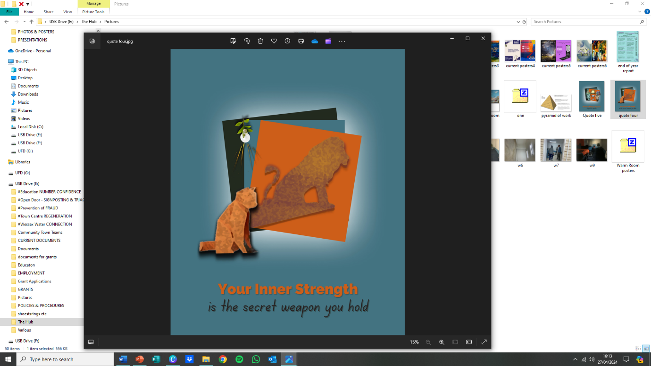
Over the year there were often baffling demands from the Evolve accountancy team and debt collecting agencies for rent/insurance payments that had clearly been paid, and many hours were taken proving, and reproving, these facts which did nothing to assist in the smooth administrative running the Hub.
There were also many unanswered enquires regarding the security of the lease, but in February 2024 it was confirmed that the lease would not be renewed at the expiry date of January 2025.
The combination of this administrative chaos dealing with the landlord’s finance departments, and the insecurity of tenure (information was also received that the premises would be widely advertised during the summer of 2024 with the break clause operated if appropriate alternate tenancy was found) led to an extensive search for new premises.
Demand for services at the Hub were also outstripping space with a waiting list for some social inclusion schemes in operation.
After several false ‘dawns’, a new site was successful found within the town centre with a floorspace of 2,400 sq. ft which was double that of No.23.
Work began to secure a five-year lease and access grants to facilitate the move and by year end both had been achieved with a moving date of mid-July 2024.
With the philosophy that the Hub will respond to any local demands that are not being addressed, the workload needed addressing and a clarity of purpose required to progress and address the question of just what the Hubs work involves, and in response six areas of work have been classified and the following agreed upon:

- WESSEX WATER CONNECTIONS
Project scope: Provide better access to advice and support during the cost-of-living crisis and the work of Wessex Water.
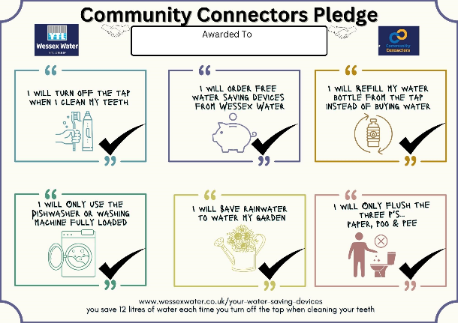
Objectives: Ensure face to face consultation to establish the appropriate road toward solution to the problems presented dealing with the whole person not just the presented problem. Education regarding where our water comes from and safe disposal of tablets.
Goals: Offer Support toward appropriate referral assistance with crisis management to avert the spiral of associated problems.
Financial considerations:
A grant of was awarded by the Wessex Water Connectors Project.
** Project ends April 2024 and will then give way to a new area of work and income “Targeting Health Inequalities”.

- NATIONAL NUMERACY
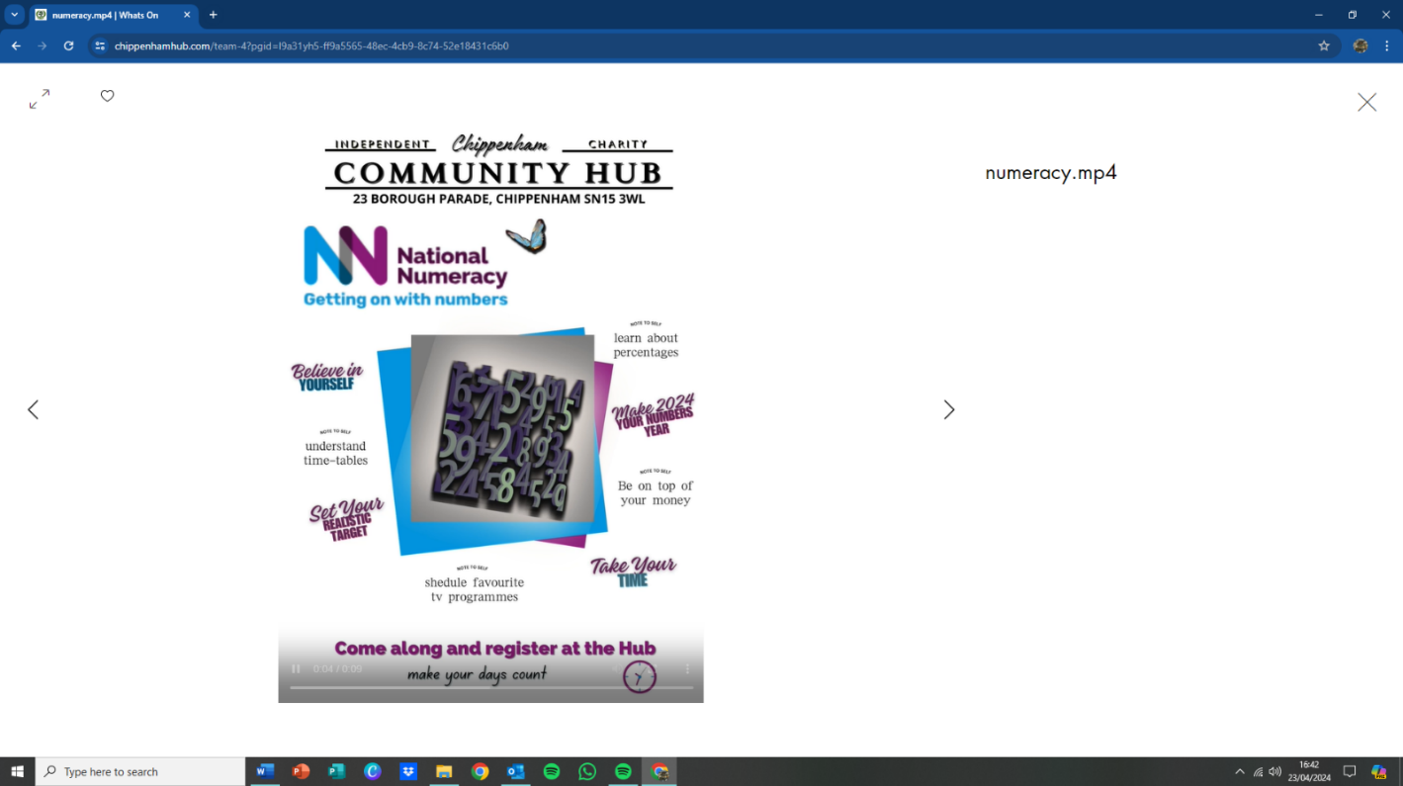
Project scope: Thirty minutes per week per person registered. On the third week to sign up to the national numeracy to begin personal journey
Six-week duration to continue and if still require, other math related sessions (given space) with more bespoke coaching.
Administered by four registered and trained Hub trustees, staff, volunteers.
Objectives: Improve basic national numeracy.
Provide better access to advice and support during the cost-of-living crisis.
Continual assistance with personal development to allow improvement after an online assessment.
Goals: Combat any personal phobias with maths.
Give basic skills for life using maths.
Produce a log for all to progress and grow in confidence with this ability.
Financial considerations:
Financial support from Skills for Life and National Lottery.

SIGNPOSTING & ADVICE
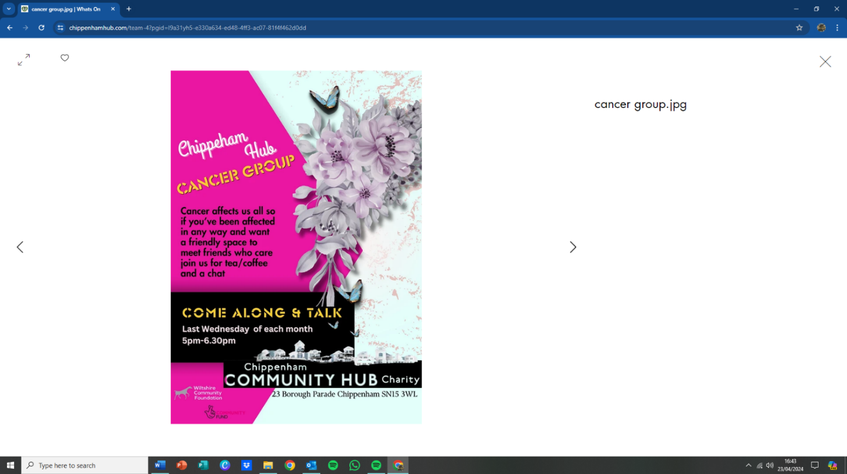
Project scope: People are complex! When someone appears at the Hub for advice it rarely a ‘one dimensional’ problem and it is the job of the trained Hub staff and volunteers to work with the individual to enable solutions by signposting the person to those who are trained and have the resources to offer the help that is needed.
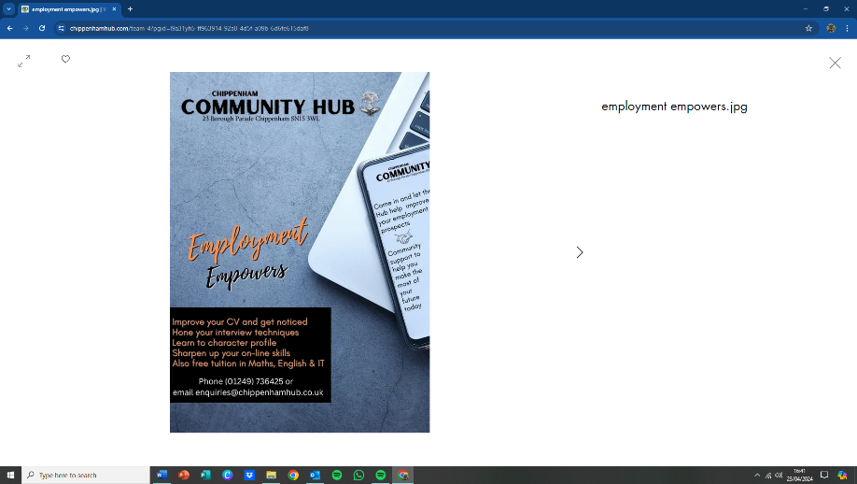

Objectives: To give advice and direction.
To treat every enquirer with respect, affording individual consultation as appropriate to address the advice or support needed.
Ensure that all advice is supported with follow-up direction.
Be led by the individuals’ goals and objectives.
Goals: To ensure, where possible, that ‘Rays Law’ is achieved with professionalism and within laid down guidelines and procedures.
To form advice and support groups as appropriate.
Financial considerations:
Made possible by grant from National Lottery.

- FRAUD PREVENTION
Project scope: There is only one Fraud Prevention Officer (FPO) for the whole of Swindon and Wiltshire, and yet this one area of criminality accounts for 45% of crime in our county.
Working locally in our town we are providing a safe local space with trained staff where people can come along and talk about their fraud experiences and get advice/signposting.
The Hub hosts informative sessions and includes regular social media postings under the strapline of ‘Together we can Kick Fraud Out of Our Town’.
This has been successful both locally and nationally, and it is a scheme that is about to be rolled out to other towns in Wiltshire.
Objectives: Support, information, signposting.
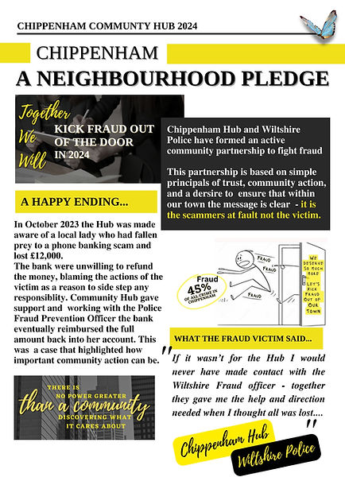
It is almost always true that people who have been scammed blame themselves, but at the Hub we emphasise that it is the scammer, not the scammed, who are the ones at fault.
Contrary to this, but because of this self-perception, it is often found that those who have been scammed will not see themselves as victim and will refuse to make a report to Victims Support, and without these actions their statistics do not reach the FPO.
Goals: The goal is to be the go-to ‘arm around the shoulder’ and information point that is so needed by victims of this crime, and alongside this is to both assist the police with ‘on-the-ground’ information and to help publicise national campaigns for trending iterations of fraud. Continuous training for staff and volunteers is essential to keep up with this every expanding area of crime in our town.
Financial considerations:
Made possible by a small grant from the Police Commissioners Fund and the National Lottery grant.

- COMBATING SOCIAL ISOLATION
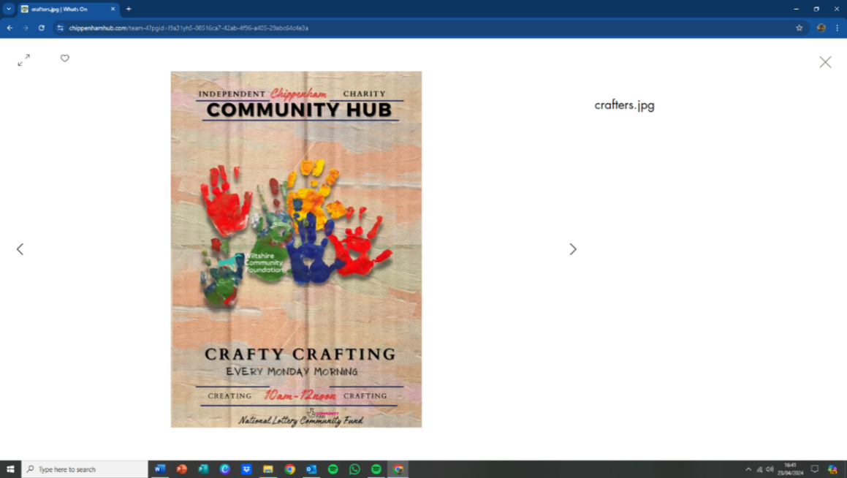
Project scope: This project has no beginning or end date; it grows exponentially according to the needs of the community and is one of the core historic reasons for the formation of the Hub post covid.
While we endeavour to deliver group sessions in specific areas to help combat this, there is also great scope for groups that just get likeminded people together to talk, play games, take part in quizzes, or simply be.

Objectives: The simple objective is to offer a safe, warm, non-judgemental, and welcoming place in which people can be encouraged to visit and move outside of the ‘safety’ of their own home space. Social isolation and loneliness can be as big a killer as any physical disease but is one that can be so effectively eradicated with love, time, facilities, and focus.
Goals: To continue in the offer above enabling those that suffer isolation to means to access a safe place in which they feel welcome and can form relationships according to their personal requirements.
The ability to move on to other less supported activities when ready is encouraged by the formation of friendship networks.
Financial considerations:
Made possible by a grant from the Wiltshire Community Foundation Social Isolation fund, contributions from participants, local business donations, and the National Lottery grant.

- HEALTH & WELLBEING
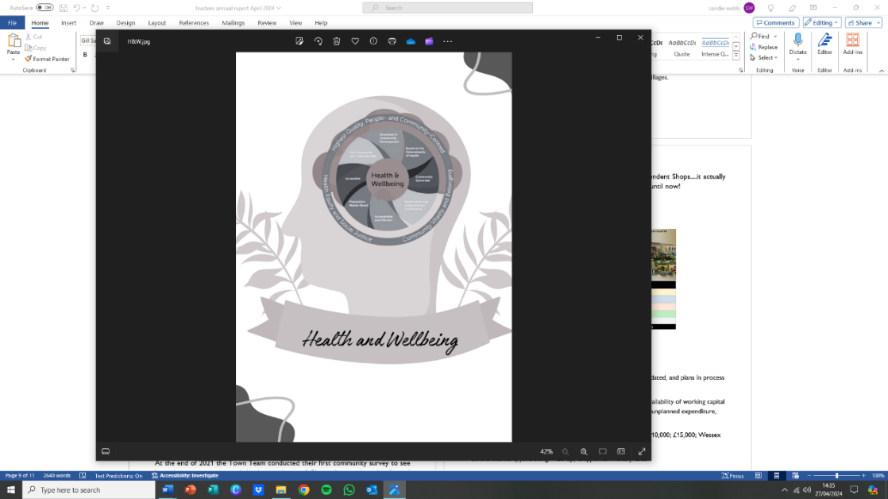
Project scope: The Health and Wellbeing Team are a proactive, cross-discipline, group of people from both the statutory and voluntary/community who are led by actions, collaboration, and deeds, to improve the lives of those who live in Chippenham and the surrounding villages.
Objectives: To network and promote positive health and wellbeing throughout Chippenham and its adjacent villages. A one stop shop for positive mental health and social inclusivity.
Goals: To enable an understanding between the Chippenham neighbourhood and its voluntary and statutory organisations.
Work with, and promote, good mental and physical health for all members of the community.
To provide the opportunity for members to network and share information about organisations and projects providing health and social care services in the area and raise awareness about any issues in the provision of health and social care.
Financial considerations:
No financial income but a joint project hosted by Chippenham Borough Lands Charity.
** Project ends April 2024 when this will become the sole responsibility of the Hub and an application will be made to Chippenham and Villages Area Board for funding to cover costs alongside the contribution toward the Hub administration by the National Lottery.
- TOWN CENTRE REGENERTION
Project scope: After the pandemic there was an increase in the numbers of people coming into the town centre for recreational reasons because it offered a great place for the community to get together, to linger, and to belong.
This proved not to be just a 'post covid trend' and it is something that continues to this day. It is a also a trend that is seen national and will contribute to the way in which our town develops into the future.
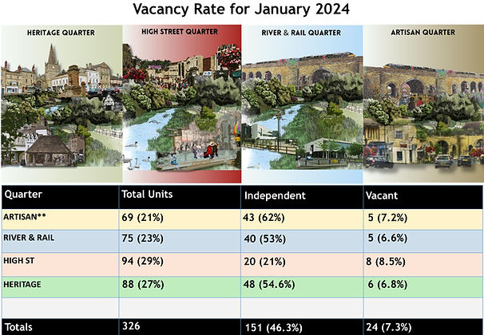
With no BID, Chamber of Commerce, or other organisation in the town and little reference to this area of town life in the Corporate Strategic plan of the Town Council, the formation of community groups, with both business and neighbourhood members, makes this project one that is ongoing with its scope only restricted by available finance and individual commitment.
Over the past three years the movement has grown exponentially, and there is no reason to expect this level of work and engagement to reduce in the coming years.
Objectives: The purpose of CCTT is to bring together members who have an active interest in the regeneration, economic development, and future of Chippenham town centre.
The creation of four Quarter, each with its own working group, allows for appropriate Place Making that is based on each area’s requirements with an overarching Town Team that is working closely with the MP led Chippenham Partnership Board.
Through the chair it is a member of the influential Institute of Place Management, which is based at Manchester University working on the various iterations of town centre regeneration.
All members of the movement abide by the guiding principles demonstrated in its Terms of Reference.
Goals:
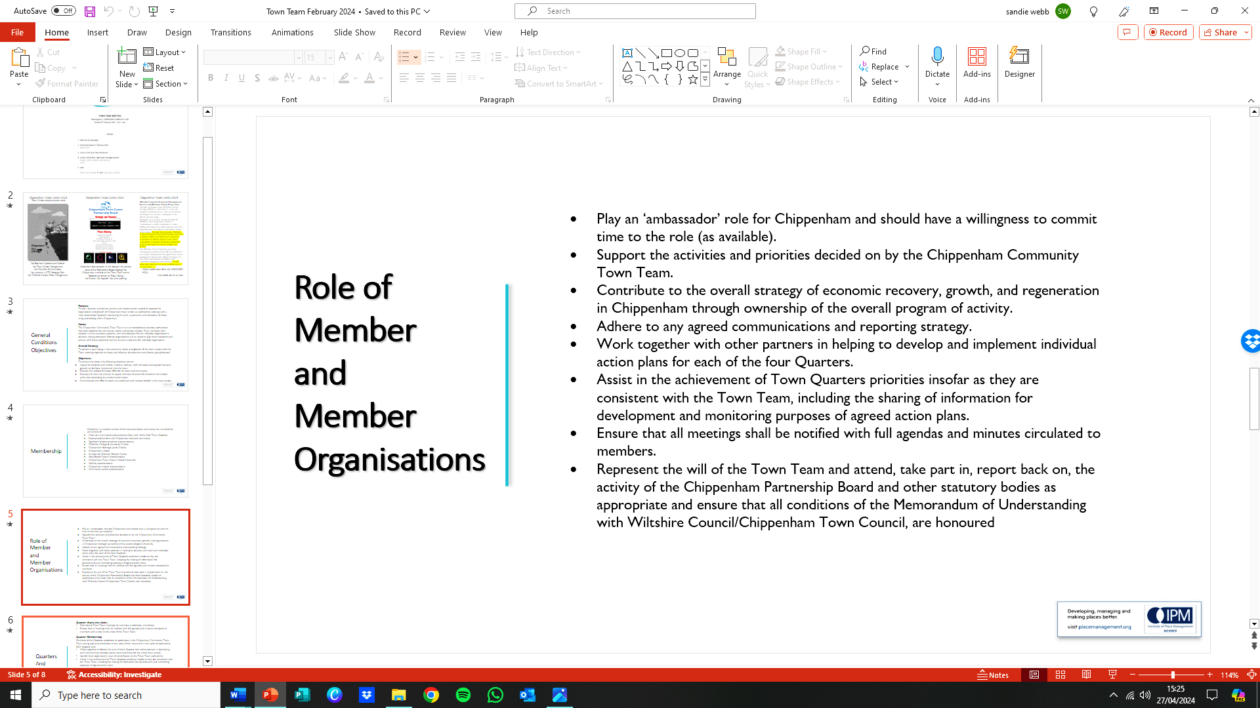
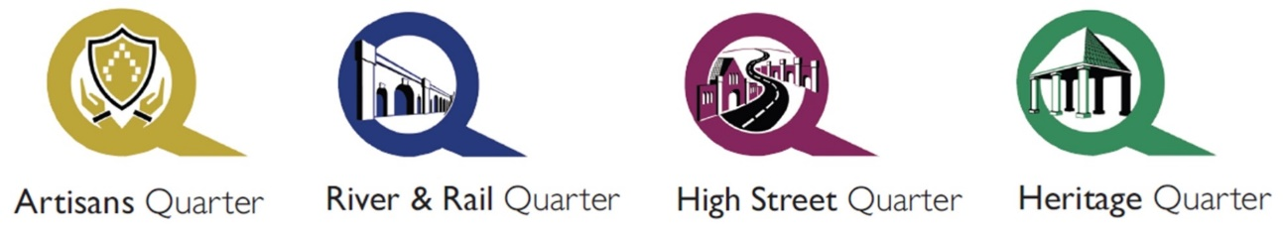
Financial considerations:
Administration support by the National Lottery grant and working toward a new partnership with Wiltshire Council, Chippenham Town Council, and significant business partners during 2024/2025.
Other considerations/significant activities
Business Impact Assessment and Plan: This has been produced and updated.
Finance Review: The reserves policy was to maintain to ensure availability of working capital for a period of three months of running costs, and despite some unplanned expenditure and an increase in expenditure due to demand, this has now been increased to four months.
Principal sources of funding: National Lottery, Wessex Water, Screwfix
General fundraising/in kind/volunteers/trustees/manager; Tesco’s; Waitrose; Morrisons; Shoestrings Foodservices; Waterstones; Nat West Bank; Crochet group; Crafty Crafters Community groups and members of the Chippenham community.

Social media: - www.chippenhamhub.com; www.chippenhamcommunitytownteam.com
Facebook: chippenhamhub
Twitter: @chippenhamhub
Instagram: Chippenhamhub
Linkedin: chippenhamcommunity MIPM

Trustees: Sandie Webb, Founder and Chair of Trustees; Ross Henning, Maintenance Trustee; Ian Hibberd, Education Trustee; George McCaffery, Grants Trustee

The trustees declare that they have approved the trustees report above.

George McCaffery…………………………Dated………………….

Ian Hibberd………………………………...Dated………………….

Ross Henning………………………………Dated………………….

