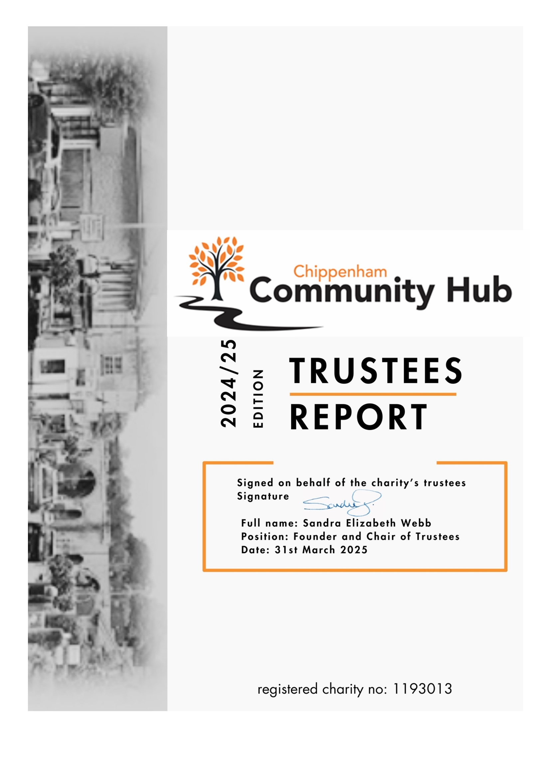

Trustees Report Year Ending 31 March 2025
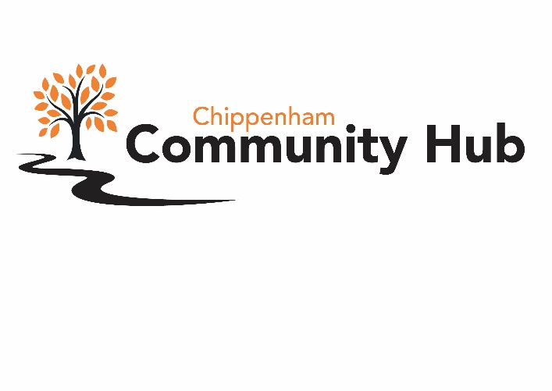

History

The Hub opened its doors post-covid following observations that, despite there being many organisations and groups that responded to consequences of the pandemic, there was no central town hub to co-ordinate, assimilation of need, and signposting.
This recognised need resulted in a small team establishing a totally independent charity that was registered as the Chippenham Community Eco Hub but is now commonly known as Chippenham Hub.
Some capital funding was established alongside a seed-funding grant from Chippenham Borough Lands Charity who contributed towards the cost of employing a manager for the first two years.
The main philosophy was, and is now, that all actions and direction is based on the premise that ‘if it is good for Chippenham, legal, and possible we will attempt to assist’.

Vision

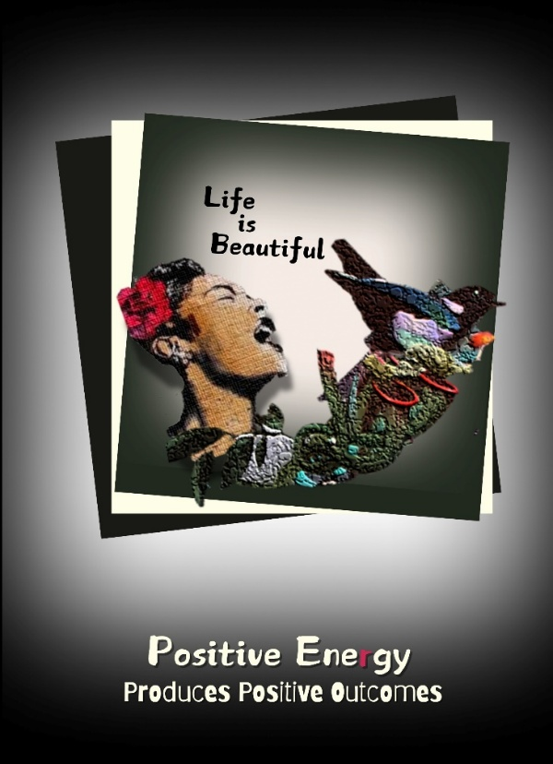
Chippenham Community Hub puts the needs of the community above all other considerations to serve the neighbourhood of the town and surrounding villages.
Day-to-day actions are based on ‘Rays Law’ that when something or someone comes through the door with a problem, on the way out they should be in the process of or travelling toward a solution.
This basic philosophy applies to both individuals and areas of Chippenham life that is not being addressed by others.

Charitable Objectives and Aims

- Operate for public benefit.
- Promote social inclusion/relief of poverty.
- Signpost and disseminate people’s needs to registered organisations/charities.
- Promote sustainability and environmental responsibility.
- Operate independently for public benefit.
- Work for, and be guided by, the needs of the community.
- Assist community agencies & neighbourhood groups to offer a range of activities/services and respond to community needs.
- Encourage social inclusivity through group activities
- Act as a place of learning, education, and skills development to facilitate employability
- Provide a non-threatening equal opportunity environment for the community to become involve aware of opportunities.
- Offer multiple services under one roof that meet the needs of the local community by encouraging social gatherings while also offering support.

2024/2025

In its fourth year the Hub has met challenges and responded to changing demands of the community while ensuring a thriving base for the local community by:
- Providing a safe, warm, and welcoming environment with consistent opening hours and messaging.
- Working with organisations embracing a portfolio of best practice ensuring that all necessary policies and procedures are in place.
- Addressing and responding to both ongoing local and national community demands and needs.
- Continuing to build partnerships to ensure effective referral routes to address visitors needs by signposting to appropriate services.
- Continuing to grow the regeneration vision of Chippenham town centre by the community for the benefit of both its residents, traders, and the surrounding villages.
- Promoting and working to achieve positive mental and physical health with social inclusion measures.
- Working to unify the statutory organisations and groups that offer Health and Wellbeing.
- Engender a positive environment where community comes first, and people always come before politics and personal agendas.

Operational Considerations

The Hub has a board of four trustees who meet regularly with agendas and recorded minutes, and the day-to-day work is led by the Development Manager, Chair of Trustees, part-time staff, and well-trained volunteers who act with the underlying philosophy of a local approach whilst also being essentially holistic and inclusive.
The work accords with, and supports, the objective “to undertake initiatives throughout the community to enhance educational, economic, environmental need and social potential “.

The independence and self-sufficiency of the Hub has been a cornerstone to the way it operates - putting people and the community at the front of all work streams and of decision making.
While this is the backbone to the organisation, there is also flexibility to accommodate and work with others, which is an area that has shown the greatest progress during a year full of unexpected twists and turns.
The fundamental elements of CCHC’s business development will continue to be dependent on building mutually beneficial relationships with the community and its base organisations.
The Hub consistently supports and attracts those experiencing, or at risk of, social and/or economic exclusion and as an inclusive organisation the priority groups include: -
• Older people
• Carers
• People with disability
• Those on low income
• People most marginalised from paid employment
• Local ethnic minorities, immigrants, refugees
• The LGBT+ community

Partner Organisations and Community Activities:

Wiltshire Council; Department for Work &Pensions; Chippenham Health and Wellbeing Team; Chippenham Community Town Team and Chamber; Cast-off Knitters; Chippenham Artists; Wiltshire Sight; Rethink Mental Health; Wiltshire and Swindon Youth Commission; North Wiltshire Community Club; Afritha Lace Makers; Chippenham Borough Lands Charity; Wiltshire Police Anti-Fraud; Doorway; Samaritans; Wiltshire Read Easy; Waste Not Want Not; Wiltshire Scrapstore; Wiltshire Centre for Independent Living; Unity House; Alzheimer's Support; Chippenham Rotary Club; Calne Transport for the Disabled; Christians Against Poverty; Citizens Advice Wiltshire; Helping Victims of Domestic Violence; Turning Point; Fighting Food Hunger in Wiltshire; Ivy Wildlife; Hathaway Surgery; Talk Big C; Warm Room Initiatives; Victim Support.

Compliance with local strategies

There are evidential links to wider community benefits which identify CCHC and the activities that are being addressed to reduce social exclusion and transform the community. In addition, the activities engaged in at the Hub have an impact on learning, culture, leisure, healthier communities, and older people.

Business Principles

The CCHC approach is underpinned by social commitment together with four core ethical starting points for community development – Transparency, Accountability, Openness, and Inclusivity.
Legal policies and procedures are in place that reflect current best practice.
Significant staff and volunteers are DBS checked with significant First Aid training undertaken.

Main areas of work and challenges during the year

After a busy and successful three years of operation, the establishment of sustainability was the main aim to achieve in the fourth year, but events proved this to be a difficult aim to achieve.
Following much work by trustees, a three-year grant from the National Lottery had been awarded in October 2023 which secured the appointment of a Development Manager together part-time posts to assist with administration and the ever-increasing workload and although the process of recruitment was not quick or easy, the start of the new financial year in April 2024 saw all posts filled and training complete.
While this signalled progress, there was a still a shadow over the aim of sustainability as it had become clear that not only was the two-year premises lease, which had been signed with Evolve Estates in January 2023, unlikely to be renewed when it came to an end, but also that it was the intention of the company to widely advertised the premises during the coming summer months with the three-month break-clause that was written into the lease triggered if an appropriate alternate tenancy was found.
This, of course, led to an extensive search for new premises and with demand for Hub services at No.23 outstripping space available, which was resulting in a waiting list for some of the social inclusion schemes, it was clear that any new accommodation would need to be larger to fulfil the growing needs of the community.
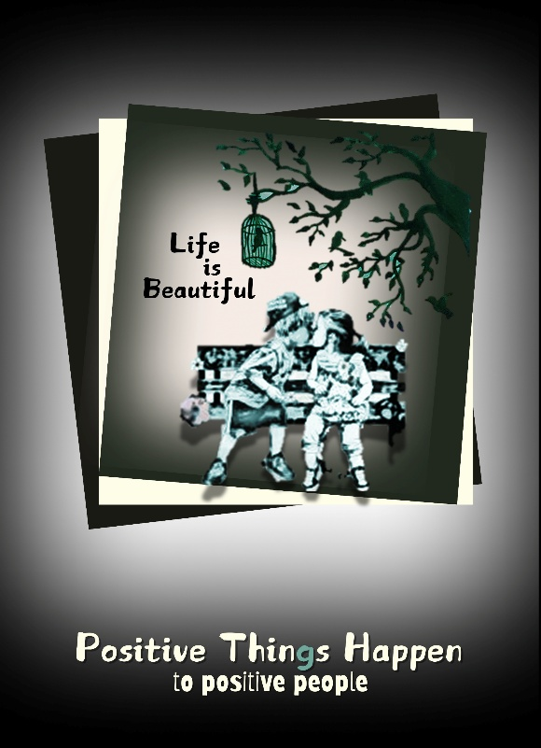
After several false ‘dawns’, a new site was successful sourced within the town centre and with a floorspace of 2,400 sq. ft - double that of No.23. There was, however, a problem as the new space had been unoccupied for a couple of years and the sum of the accommodations was contained in one large unsegregated area which would require much work to enable it to become a community hub. A grant to cover this was successfully applied for from the Wiltshire Council’s Towns Programme, and this enabled both the building work and essentials such as WIFI to be installed.
All the while the community work continued as usual with a plan to cause the minimum disruption possible during the move for those who relied on the Hub.
With a full work itinerary and everything in process, it was, therefore, very worrying to be presented with a huge bill for over £17,000 by the landlords of Borough Parade, Evolve Estates, for a never-ending list of ‘perceived’ work required on vacation of the premises together with renumeration for legal/professional fees etc.
This additional burden meant that behind the scenes pressures were building.
By the end of June, a five-year lease had been signed for the new premises, grants had been put in place to facilitate the move, and all was on course for just one week’s closure at the beginning of July 2024.
However, life can at times be cruel and we were about to face a torrid time that none could have predicted.
Just as the move week came along three key members of the Hub were hit with Covid, and while two thankfully soon recovered, our valued Development Manager was left in hospital fighting for her life.
Despite all the conditions that were so challenging, the Hub was only closed for the planned week, walls were built, moving completed, and the new Chippenham Community Hub began welcoming back friends old and new with a mask of calm -albeit with so much still being dealt with behind the scenes.
A month later the Hub welcomed back its manager and hard negotiations with the old landlords had resulted in their demands being negotiated down to afford as little expenditure as possible – money that was then covered by a rent-free period negotiated with the new proprietors.
It was amazing how the community of Chippenham took to the new Hub at No1 and by the time September came along new systems were being introduced, three new letting rooms were up and functioning, and the reception area had taken on a welcoming and informative persona where curiosity at this new Hub was being quenched.
All was calm again with room hire, social inclusion groups, meetings, and the operation of the Hub open door policy all settled into a steady and comforting rhythm for the benefit of the Chippenham community.
A new working relationship was also established with Chippenham Borough Lands Charity who were looking for a town centre space to operate their local grant giving work once a week. At first, they hired a space for the consultations, and subsequently then awarded the Hub a substantial three-year grant award toward the cost of the rent of the new premises.
Links with other organisations and groups have also been greatly improved since the move with both the Health and Wellbeing and Town Team movements attracting partnerships and assisting in one of the Hubs a core aim of uniting statutory authorities and other charitable groups in the Chippenham and surrounding areas.
There has been continuing improvement in data collection and reporting, and this will continue to be a challenge that staff, trustees, and volunteers will work on in the coming months together with increasing the Hub’s profile.
However, no matter what progress is being made, there is always tomorrow and the ever-changing needs of the community to focus on.
MAIN AREAS OF WORK

Targeting Health Inequalities – Downtown Days

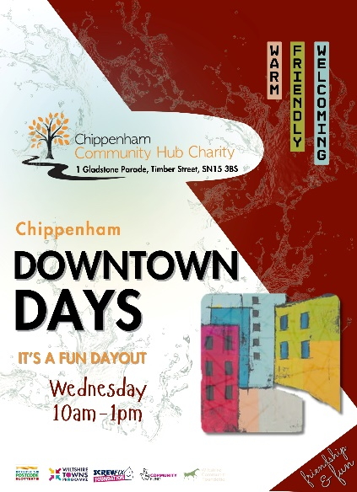
Project scope: Although it is distance from the town centre that a healthy person would find easy to walk, this is not so for anyone who is house bound, elderly, or with any mental or physical disability.
The scope of this project was to encourage residents from the Queens East area of Chippenham to once again go ‘downtown’ by providing transport. While the Hub was the destination, the function was seen to be one of a ‘safe house’, area rather than a destination, where activities are agreed by those present.
It was the ultimate social inclusion exercise run by the people, for themselves and as such had only outline scope.
Objectives: Queens East is an area of the town where social isolation is high and there are some residents who have not ventured out of their homes since covid.
It is intended that the group of people who attended this weekly session would become inter-reliant and shape not just the few hours at the Hub but also carry this on into their neighbourhood; acting as a cohort for the Community conversation project that is run by Wiltshire Council to improve what is, the most deprived area of Chippenham.
Goals: Whilst the goals were not firmly defined, the results have been quite spectacular with the group indeed using the Hub as a base to go to other venues and activities in the town centre, but the most significant result has been the interaction between the members of this group and their neighbourhood at other times in the week. Friendships have been formed and both the Community Conversation project and subsequently the ‘Why I call Chippenham Home’ project (the title determined by the group) have grown because of Downtown Days.
When the funding comes to an end the aim will be to continue this (see below for details)
Financial considerations: A grant of £9,450 was awarded by the ICB which included £4,500 for the cost of transport.
** The funding runs out in June 2025 at which time the group will be included under in the general SOCIAL ISOLATION area of work as one of the group areas, but transport will not be included.

National Numeracy – Multiply

Project scope: Basic Maths training delivered to the community in ½ an hour session for 6 weeks at a time and if needed they would continue.
Hub staff and volunteers were trained by National Numeracy with number confidence and became community champions.
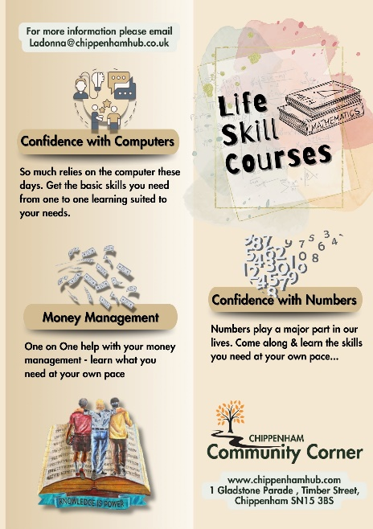
Courses were specific to the individuals and there was great success with assisting people that enrolled with time telling, travel planning, time sheets for work and many more basic life skill achievements.
Wiltshire County Council were impressed with the Hub’s delivery of this service for the funding and used it as a role model for delivery and development for other fund receivers.
Objectives: Improve basic national numeracy.
Provide better access to advice and support during the cost-of-living crisis.
Continual assistance with personal development to allow improvement after an online assessment.
Goals: Combat any personal phobias with maths. Give basic skills for life using maths.
Produce a log for all to progress and grow in confidence with this ability.
**All goals were achieved for each of the community members enrolled and many are still requiring further training in Job coaching, Maths, English and IT – bee below.
Financial considerations: Financial support from Wiltshire Council and nationally via Skills for Life. Funding from the National Lottery enabled staff participation.
** The scheme has now closed but it was found people were coming in to register with a need for the various coaching courses. This will be replaced by Community Corner Coaching with skills acquired previously enabling various Hub members to launch this new initiative.
A volunteer has been recruited from the ‘Downtown Days’ group who will teach I.T. assisted by a staff member; a volunteer and a trustee will teach Maths; and the Hub manger will continue to offer job coaching sessions.
Funding for the Community Corner Coaching is being sourced and there are already seven people signed up: - 3 x maths; 1 x English; 2 x Job Coaching; 1 x I.T.

Signposting and Advice

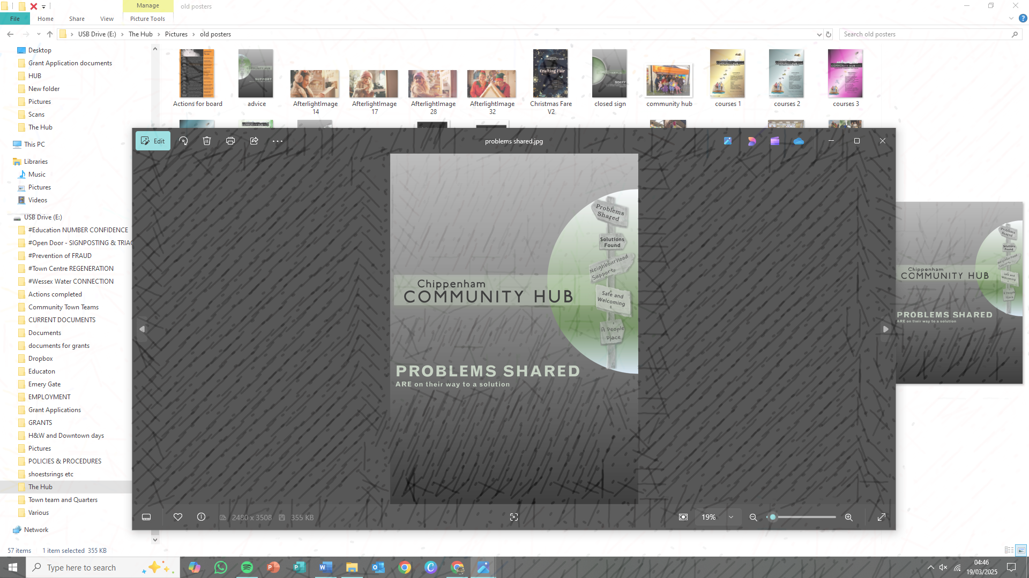
Project scope: People are complex! When someone appears at the Hub for advice it rarely a ‘one dimensional’ problem and it is the job of the trained Hub staff and volunteers to help that individual unravel the problems and enable solutions by signposting to those who are trained and have the resources to offer the help that is needed.
Objectives: To give advice and direction.
To treat every enquirer with respect, affording individual consultation as appropriate to address the advice or support needed.
Ensure that all advice is supported with follow-up direction.
Be led by the individuals’ goals and objectives.
Record and review all actions.
Goals: The Hub attempts to always be mindful where possible, of ‘Rays Law’ that states – If a person comes through the door with a problem when they leave, they are on the way to solution if at all possible. This also applies to areas in the community that need addressing but which are not being acted on locally, either in an official or voluntary capacity. Within that process, if necessary, the Hub will form advice and support groups as appropriate.
The Hub will always ensure that our staff, volunteers and trustees will act with professionalism and within laid down guidelines and procedures.
Financial considerations: Grant funding for staff from National Lottery.

Fraud Prevention

Project scope: There is only one Fraud Prevention Officer (FPO) for the whole of Swindon and Wiltshire, and yet this one area of criminality accounts for 45% of crime in our county. Working locally in our town the project provides a safe local space with trained staff where people can come along and talk about their fraud experiences and get advice/signposting.
By holding informative sessions and regularly postings on social media under the strapline of ‘Together we can Kick Fraud Out of Our Town’ fraud is kept in the eye of our Chippenham residents.
Objectives: The main objectives are support, information and signposting. It is almost always true that people who have been scammed blame themselves, but at the Hub we emphasise that it is the scammer, not the scammed, who are the ones at fault. Contrary to this, but because of this self-perception, it is often found that those who have been scammed will not see themselves as victim and will refuse to make a report to Victims Support, and without these actions their statistics do not reach the FPO.
The objective in 2024 was toward the older residents of the community but having been successful with this age group for a couple of years, the new area of concern and work will be with the 13–19-year-old social media obsessed age group.
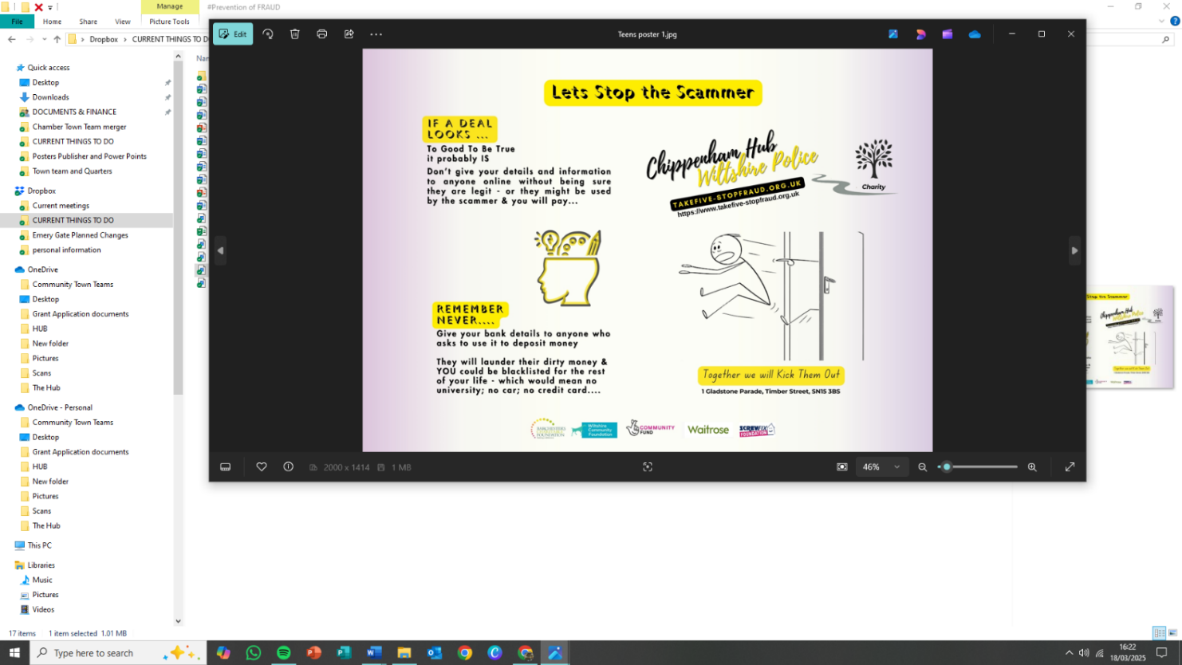
Goals: One goal is to still be the go-to ‘arm around the shoulder’ and information point that is so needed by victims of this crime, but alongside this is it is to both assist the police with ‘on-the-ground’ information and to help publicise national campaigns for trending iterations of fraud.
Continuous training for staff and volunteers is essential to keep up with this every expanding area of crime in our town and it will be essential to make the Hub available to the schools and professional organisations involved in the new youth movement according to their needs.
Financial considerations:
This project was initially made possible by a small grant from the Police Commissioners Fund, but a second application was refused due to the 2025 criteria of only seed funding new applications.
An application to the High Sherrif fund was successful and this will now be used to work with the Fraud Prevention officer, Hardenhuish School, and the Family Centre to highlight areas of fraud that are particularly significant for those in the age group 13-19 years
This new area of work will be led by the professional organisations who will direct the project at the Hub.

Combating Social Isolation

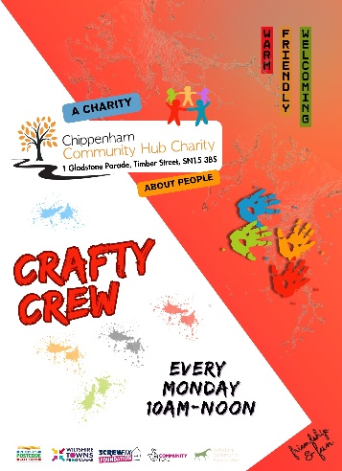
Project scope: This project has no beginning or end date; it grows exponentially according to the needs of the community and is one of the core historic reasons for the formation of the Hub post covid.
While we endeavour to deliver group sessions in specific areas to help combat this, there is also great scope for groups that simply get likeminded people together to talk, play games, take part in quizzes, or simply be.
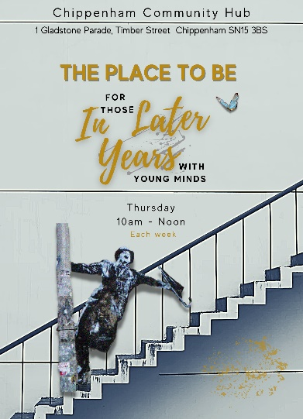
Objectives: The simple objective is to offer a safe, warm, non-judgemental, and welcoming place in which people can be encouraged to visit and move outside of the ‘safety’ of their own home space. Social isolation and loneliness can be as big a killer as any physical disease but is one that can be so effectively eradicated with love, time, facilities, and focus.
Goals: To continue in the offer the above enabling those that suffer isolation have access to a safe place in which they feel welcome and can form relationships according to their personal requirements.
The ability to move on to other less supported activities when ready is encouraged by the formation of friendship networks.
Financial considerations: A new grant from the Wiltshire Community Foundation Social Isolation fund has been applied for and there are session contributions from participants, local businesses and other grant givers.

Health & Wellbeing


Project scope: The Health and Wellbeing Team are a proactive, cross-discipline, group of people from both the statutory and voluntary/community who are led by actions, collaboration, and deeds, to improve the lives of those who live in Chippenham and the surrounding villages.
Objectives: To network and promote wide ranging areas of positive health and wellbeing throughout Chippenham and its adjacent villages and be a one-stop-shop for positive mental health and social inclusivity.
Goals: To enable and coordinate an understanding between the Chippenham community within its voluntary and statutory sectors.
To work with and promote good mental and physical health for all members of the community.
To provide the opportunity for members of the group to network and share information about their work and projects providing health and social care services in the area
To raise awareness about any issues in the neighbourhood provision of health and social care.
Financial considerations:
** Contribution from the National Lottery toward staffing costs

Membership

Town Centre Regeneration

Project scope: Following the pandemic there was an increase in the numbers of people coming into the town centre for recreational reasons because it offered a great place for the community to get together, to linger, and to belong.
This proved not to be just a 'post covid trend' and it is something that continues to this day as a trend that is growing. The Town Team movement is acknowledged for its work nationally facilitates participation by the business and community to contribute to the way in which Chippenham centre is developing.
The Town centre movement will continue to grow in influence and membership without financial barrier, because member give their time for free.
Its scope is only restricted by individual commitment.
This is a vital area of community work that will enable each neighbourhood to retain a sense of identity and belonging for both new and existing residents.
Over the past three years the movement has grown exponentially, and there are no indications that this level of work and engagement will reduce in the coming years.
Objectives: The purpose of CCTT is to bring together business and community members who have an active interest in the regeneration, economic development, and future of Chippenham town centre.
The creation of four Quarter, each with its own working group, allows for appropriate Place Making that is based on each area’s requirements with an overarching Town Team that is working closely with the MP led Chippenham Partnership Board.
Through the chair, it has membership of the Institute of Place Management, which is based at Manchester University working on the various iterations of town centre regeneration.
All members of the movement abide by the guiding principles demonstrated in its Terms of Reference.


Goals: Be a representative structure to ensure each area of the town has an input into Placemaking of the town centre, today and into the future.
Enable independent collective actions to form a vibrant and sustainable town - fostering a sense of ownership, pride, responsibility, and connection to space.
Ensure that both small and medium sized businesses and their entrepreneurs can contribute to a thriving local economy and provide employment opportunities.
Work with other organisations to define clear and achievable goals for regeneration projects that incorporate a wide range of aspects such as the characteristics of quarters, economic growth, business support, cultural enrichment, green spaces, and infrastructure.
Address the absence of a Chippenham Chamber of Commerce and BID
Financial considerations: Administration support by the National Lottery grant

TESTIMONIALS

RAY’S STORY

During the transition period of moving Hub’s to our new abode we had a lovely gentleman introduced to us called Ray who was keen to socialise and gain more confidence within himself.

Ray initially was recommended to undertake Maths with us under the Multiply Project and he was given Maths training for 12 weeks. These were basic Maths skills and growing confidence. It was apparent that Ray was struggling to read the questions, and he needed assistance. Ray had developed his own coping skills with his fantastic ability to use memory and was able to get by with using this technique.
As a Hub we referred Ray to Read Easy and they have just come back and had a meeting with him to discuss his needs. We also signed him up for Wiltshire Family Community Learning and he has done English with a 2-step course to help and adjust his learning ability. We have also backed this learning up by working with the teacher and growing on the reading with one-hour sessions per week from his workbook on a one-one basis. We are aware that Ray tends to read backwards and struggles with pronouncing words, so we have also spoken with the Living Well Team, and they are going to seek additional help with speech therapy, if possible, but a referral has been made with Ray’s consent.
Ray has made so much progress and would love to become far more independent and has joined other groups through our signposting like, The Shed, he takes part in the Downtown Days group and has joined up with the Camera Club with that Community Group too. He continues to go to Chippenham Collective with the therapeutic gardening and is beginning to love life after his own disabilities had made him very socially excluded.

SARAH’S STORY – in her own words…

My name is Sarah, and I was going through some extremely difficult times due to bad choices I had made in my life and wanted so badly to change my world back to some form of normality and make amends for the bad choices I had made.
I was not employed and had very low self-esteem and just did not know which way to turn. I was given support workers to assist me and although it was helpful, I was in desperate need of someone to help me get out of this big hole I had slipped in to. I was finding myself struggling to get out of bed as I had no vision of how I could turn things around in my life and I did want to do it so I could make myself proud of being able to cope. I do suffer with ADHD and various other illnesses and these I did not want to hold me back either.
I took it on myself to attend the Chippenham Community Hub one day which took all the strength in the world to do. I was so anxious to go in and talk to someone about my life, my situation, my aspirations, and the support I was needing to move on to a better path and get my life back on some sort of track. It was an eye opener as I was so surprised at how easy it was to talk to “at the time” a stranger about all the things that had happened in my life and how I was going to move forward with a way of making good choices.
After many long conversations, emails of the kindest nature and phone calls to chase me up, I was encouraged to attend the Chippenham Community Hub on a regular basis and as the support was given it gave me the opportunity to gain confidence in becoming a volunteer and giving something back to others helped me to understand myself and feel good about what I was doing. During my time of Volunteering, I was also encouraged to seek employment and given lots of support in different ideas of sectors I could possibly work within. I also attended a Maths and English Course at the Chippenham Community Hub which Wiltshire College was running there at the time.
Due to being a very hands-on person and the love of being free and working with my hands it was suggested that I should consider working in construction as I am not, a “Girly Girl” and I like working with my hands and doing creative work that I can see and love the feeling of achievement. This helps with having ADHD and the energy levels can be put to good use. There was an arranged course put on at the Chippenham Community Hub arranged with New College, Swindon for a CSCS Construction Certificate. The Chippenham Hub Manager advised that I benefit from this registration and construction would be a way forward for me and I decided to go ahead with this. I not only smashed it, but I also came tops in the class. I have gone from strength to strength and have been working with a local company covering many miles working of different projects on site and love my life. The willingness was always there but I needed the support and certainly got this from Chippenham Community Hub.
I loved being at the Chippenham Community Hub as I was allowed to be always myself and the understanding of my ways and personality but the encouragement to be pushed out of my comfort zone without me even realising, I had done the things I feared, and it was amazing. The encouragement to go on the Walkie Talkie helped me so much to get to know others too.
I will always hold them close to my heart for the help and support given to me with my journey and I always pop in and speak with them when I get the chance. The experience was precious and not having family living close it was really what I needed to get me on my way to building a better future for me and my family.

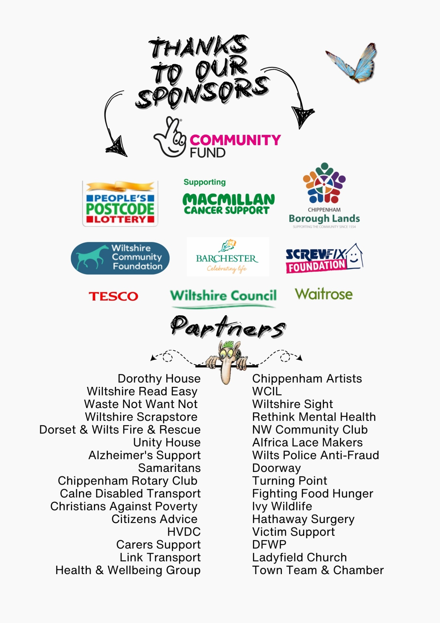

Other considerations

Business Impact Assessment and Plan: This has been produced and updated.
Finance Review: The reserves policy is to maintain to ensure availability of working capital for a period of four months.

Social media:
www.chippenhamhub.com
www.chippenhamtownteam.com
Facebook: chippenhamhub
Twitter: @chippenhamhub
Instagram: chippenhamhub
Linkedin: chippenhamcommunity MIPM

Trustees: Sandie Webb, Founder and Chair of Trustees; Ross Henning, Maintenance Trustee; Ian Hibberd, Education Trustee; George McCaffery, Grants Trustee

The trustees declare that they have approved the trustees report above.

George McCaffery McCaffery Dated 3rd April 2025

Ian Hibberd KI Hibberd Dated 3rd April 2025

Ross Henning RH Dated 3rd April 2025
Sandie Webb Dated 3rd April 2025

